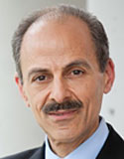
Keith T. Ayoob, Ed.D., is a pediatric nutritionist and clinical practitioner. He serves as director of the nutrition clinic at the Children’s Evaluation and Rehabilitation Center at Einstein and the Children’s Hospital at Montefiore.
Dr. Ayoob’s work focuses on obesity in children. His clinical approach takes into consideration the immediate social context of a child’s obesity problems, and includes treatment—through counseling and motivational exercises—that focuses on family dynamics. His main research interests are treating and preventing obesity; preventing type 2 diabetes; cardiovascular health; feeding problems, both physical and behavioral; and the nutritional effects of drugs commonly prescribed to children for a variety of behavioral issues.
Dr. Ayoob was instrumental in developing the NuVal nutritional scoring system, a food evaluation algorithm designed to improve consumers’ ability to quickly and accurately rate an item’s health value. He co-designed the global nutrition policy for the Walt Disney Corporation, which was strongly endorsed by First Lady Michelle Obama. He coauthored, with Barbara Hoffman, The Uncle Sam Diet: The 4-Week Eating Plan for a Thinner, Healthier America, which promotes healthy eating and an active lifestyle.
Dr. Ayoob is a fellow of the Academy of Nutrition and Dietetics and a coauthor of its position paper on food and nutrition myths and misinformation, and he has testified before Congress on the marketing of diet pills to children. Frequently called upon by the media as an expert resource, he is a recipient of the New York State Dietetic Association’s Award for Excellence in Media.

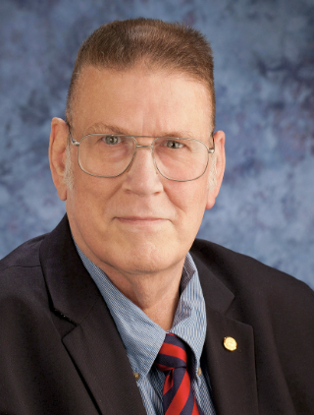
Rufus L. Chaney obtained a Ph.D. in Biochemistry from Purdue University in 1969. He worked with USDA-Agricultural Research Service for 46 years before retiring in 2016. He did research in lab, greenhouse and field on fate of metals in biosolids, soils, and crops, and the food-chain transfer and bioavailability of soil and crop metals to animals. He contributed to US-EPA rules on land application of biosolids to protect food safety and crop yields while benefitting from the value of biosolids nutrients and organic matter in crop production. He cooperatively conducted animal feeding tests to clarify how Zn in soils inhibits Cd uptake by crops, including animal feeding tests which showed that higher crop Zn strongly inhibited Cd absorption by test animals. During this work he invented the concept of soil metal phytoextraction, and from 1998 to 2001 led a Cooperative Research and Development Research Program to develop a patented complete commercial phytoextraction technology for soil Ni and Co and another for Cd. He has been advising the DOE-ARPA-E to develop a $10 million program of grants to further develop and apply Ni phytomining to provide Ni needed for the new high-capacity storage batteries within the USA (over 90% of Ni used in the US is imported). He also cooperated in development of a Cd and Zn phytoextraction technology, which is highly promising for soil Cd risk remediation. His work on bioavailability of soil Pb and treating soils with Fe-rich biosolids has also contributed significantly to present acceptance of in situ remediation of metal contaminated soils and using mixtures of biosolids and byproducts to restore ecosystems on highly phytotoxic and barren metal smelter contaminated soils and mining wastes (Zn, Pb, Ni). He has 518 publications on many aspects of Cd, Zn, Ni and other metals in agriculture and the environment.

De Ann Davis, PhD, joined Western Growers in June 2020 as Senior Vice President, Science. Davis has more than 25 years of experience in the development and execution of technical global programs, including food safety, quality assurance and regulatory compliance.
Following an impressive run in consumer products safety, Davis transitioned to packaged and fresh produce safety nearly a decade ago. Prior to Western Growers, she served as Food Safety Director for Commercial Food Sanitation, a provider of strategic consulting services, expertise and training that addresses food safety and sanitation challenges for food processing plants. Davis also served as Vice President of Food Safety and Quality for both Church Brothers Farms and Earthbound Farm, and earlier as Chief Food Safety Officer for Kraft Foods Group, where she was engaged in the development of the regulatory framework for Food Safety Modernization Act.
Davis earned her Bachelor of Arts degree in Biology and Chemistry from Point Loma Nazarene University and her PhD in Biochemistry from Texas A&M University. She is also a certified Diplomat of the American Board of Toxicology, where she has served since 1996.
Davis holds several committee appointments within the produce industry, including having recently served as the Chair of the Board of Advisors for the Center for Food Safety, University of Georgia. In 2018, Davis was appointed to the USDA National Advisory Committee on Microbiological Criteria for Food.

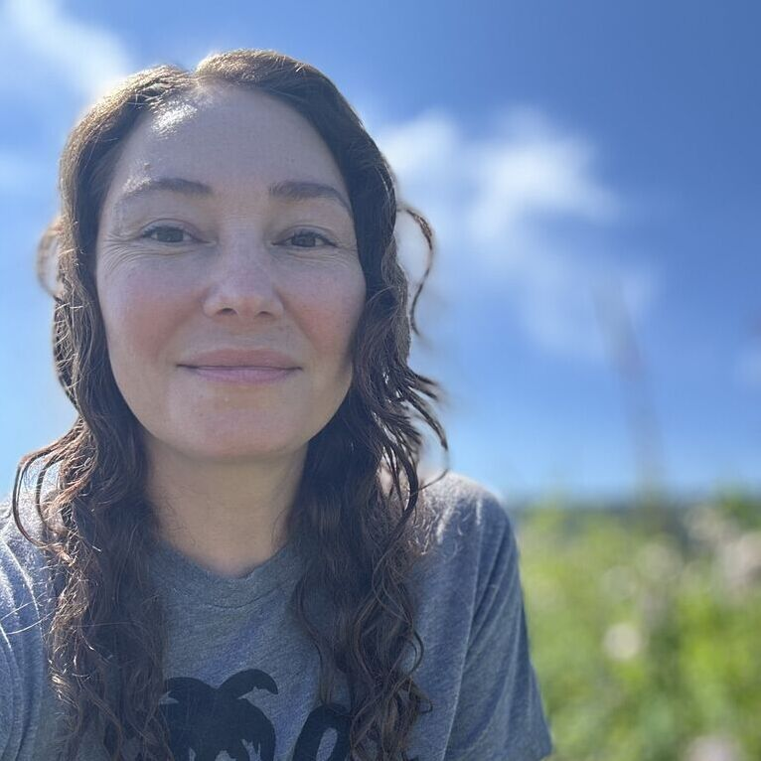
Danyelle Forte is a dedicated researcher committed to advancing the agricultural and food industries. With a passion for plant breeding, she seeks innovative solutions to the challenges of food production. As a plant breeder, she focuses on identifying optimal traits in plants and developing new varieties that exemplify productivity, nutritional quality, flavor, and resilience in a changing climate.
Danyelle is on track to graduate in June 2026 with a PhD in horticulture and agronomy, specializing in plant breeding, plant nutrition and heavy metals, and leafy greens production. Her research investigates the genetic basis of cadmium accumulation in spinach, including SNP discovery and marker development. At the same time, she is formulating a hydroponic protocol to differentiate spinach cultivars based on their foliar cadmium concentration.
Beyond her academic endeavors, Danyelle is committed to contributing to a more sustainable future. She envisions being part of a team that promotes innovative solutions while actively engaging with the community to foster awareness and collaboration in agricultural practices. By connecting with local farmers, educators, and consumers, she aims to create a holistic approach to sustainability that benefits both the environment and the community.


Stephanie Hodges (MS, MPH, RDN) is a public health dietitian and food policy professional with over a decade of experience working to increase access to healthy food through food systems, public health nutrition programs, and policy change. She is the founder and owner of The Nourished Principles, a public health and nutrition consulting firm where she works with clients to implement strong public health nutrition programs and policies, write and implement grants, strengthen nutrition and wellness within school districts, and engage and inform consumers on nutrition, and public health topics. Prior to founding her business, she worked in state government overseeing multi-million-dollar demonstration grants from USDA and working with non-profit organizations and school districts to implement and enhance federal nutrition assistance programs to advance nutrition equity. She has been quoted in national nutrition and health media outlets including Healthline and the Huffington Post and appears regularly on podcasts and local news segments to share public health and nutrition information. Stephanie earned a Master of Science in Food Policy & Applied Nutrition and a Master of Public Health from Tufts University. She holds a Bachelor of Science in Human Nutrition, Foods & Exercise from Virginia Tech and she completed her Dietetic Internship at the Medical University of South Carolina.

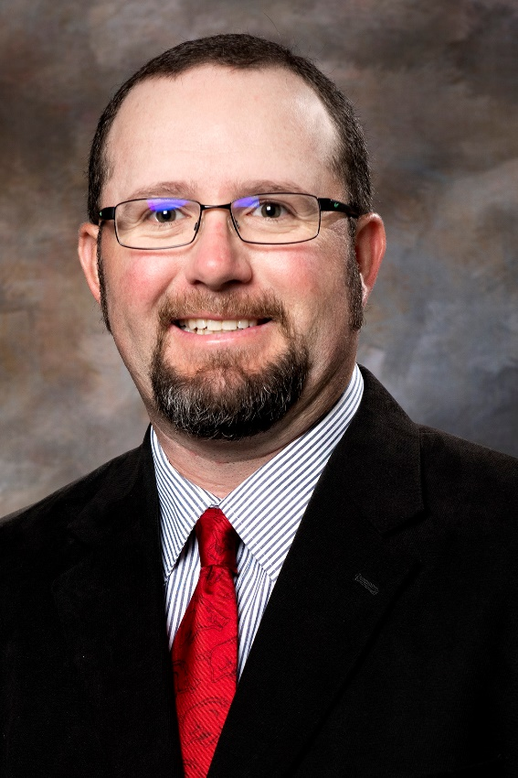
Dr. Trenton Roberts is a Professor and Interim Department Head in the Department of Crop, Soil, and Environmental Sciences at the University of Arkansas. Roberts received his B.S. in Plant Science at Oklahoma State University, his M.S. in Soil Science at the University of Arizona, and his Ph.D. in Soil Science at the University of Arkansas. Dr. Roberts’ expertise and research interests include optimizing the efficiency with which crops use essential nutrients through the development of soil and tissue tests as well as management practices such as time, rate, source and placement. Currently, his focus is on nitrogen, phosphorus, potassium and magnesium in a wide range of field crops important to Arkansas including corn, cotton, rice, soybean and wheat. Additionally, Dr. Roberts has led the Division of Agriculture’s cover crops research programs focused on the whole system approach to effective cover crop implementation. His research methods include extensive field and laboratory research. A focal point of his nitrogen research program involves the use of stable isotopes such as 15N to directly measure nitrogen recovery efficiency within research trials both in the lab and field. Research contributions in these areas have included: the development of a soil-based nitrogen test for rice and wheat, implementation of in- and post-season tissue tests for corn, rice and soybean, development of Greenseeker handheld response index for corrective nitrogen management in rice, identification of cover crops species and management for specific crop rotations, tracing nitrogen cycling through cover crops and cash crops using 15N and development of guidelines for effective use of enhanced efficiency fertilizers in Arkansas crop production systems.



Dr. Carolyn G. Scrafford is a Principal Scientist at Exponent, specializing in chemical regulations and food safety. With 20 years of experience, she applies epidemiological methods, statistics, and risk assessment to evaluate health effects related to food contaminants, additives, and environmental compounds globally. Dr. Scrafford has expertise in clinical trials, dietary risk assessments, and exposure assessments for contaminants like heavy metals and food toxins. She has supported regulatory submissions, including developing GRAS notifications and Food Additive Petitions (FAPs), using data from large international databases.
In academia, Dr. Scrafford collaborates on studies linking diet and health and teaches global child health at George Washington University. She earned advanced degrees from Johns Hopkins University, where her research focused on maternal and child nutrition. Dr. Scrafford has published extensively in peer-reviewed journals and is active in professional associations such as the American College of Epidemiology and the American Society for Nutrition.

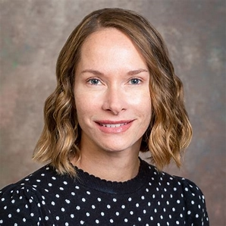
Dr. Angelia Seyfferth is a Professor in the Department of Plant and Soil Sciences, one of the founding Directors of the Center for Food Systems and Sustainability (CENFOODS), and the Associate Dean for Research in the College of Agriculture and Natural Resources at the University of Delaware. Seyfferth earned her B.S. degree in Environmental Science and Chemistry at Towson University, her Ph.D. in Soil and Water Sciences at the University of California-Riverside, and was a postdoctoral researcher in the Department of Environmental Earth System Sciences at Stanford University prior to starting her faculty position. Seyfferth’s research focuses mainly on using tools and concepts rooted in soil biogeochemistry to develop sustainable ways to lower human exposure to harmful contaminants from food. She uses both laboratory and field experiments as well as conventional and advanced spectroscopic techniques to illuminate the dynamic chemistry of the rhizosphere and to understand localization of contaminants and nutrients in soils and plants. Her research also includes understanding mineral control on below-ground carbon cycling in coastal environments that are prone to sea level rise and storm surges. She has won several awards, including the 2022 Jackson Award in Soil Chemistry and Mineralogy given by the Soil Science Society of America and the 2022 Charles S. Falkenberg Union Award co-sponsored by the American Geophysical Union and the Earth Science Information Partners.

